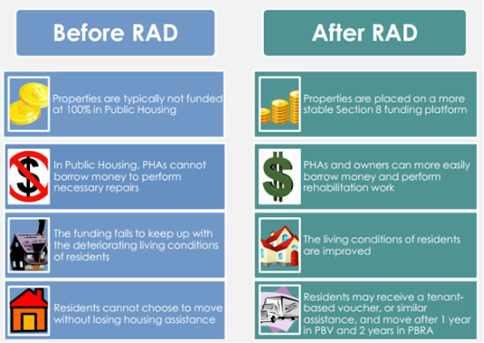
RAD frequently asked questions and answers
- What is RAD?
- Rental Assistance Demonstration, a relatively new HUD program whereby public housing sites can be converted to different types of Section 8 programs.

- What are the benefits of RAD?
A. The program funding for our sites is anticipated to be higher and more stable over time, allowing the sites to be maintained and operated to a higher standard.

- Will we lose our homes?
A. No, the RAD regulations are very protective of tenant rights. However, of course you must continue to comply with your lease, pay your rent, etc.

- Since there is no flat rent, what options would take its place?
A. The concept of flat rent does not exist in the new program. Instead, all household rents are calculated similarly to the public housing income-based rents (30% of adjusted gross household income) Residents paying flat rent now will experience a phased-in increase up to the cap of 30% of adjusted gross income.

- Why is CHA converting to RAD?
A. Under the RAD program, CHA proposes to convert several sites, including Mary Walker Towers, Boynton and Dogwood, into Project-Based Rental Assistance (PBRA) sites, a type of Section 8. The reasons are as stated above in Q2. Other CHA public housing sites may be considered for conversion in the future.

- What are the new income limits under RAD?
A. Under the new Project-Based Rental Assistance program at Mary Walker Tower, Boynton Terrace and Dogwood Manor, income limits would remain the same as public housing, at 80% of Area Median Income adjusted for family size.

- Will married couples continue to qualify?
A. Yes, of course. There will be no changes in the eligible household types under the new program.

- Will CHA continue to manage the high rises under the new RAD program?
- Yes, CHA will continue to own and operate.

- Will we need to pay utilities?
- No, CHA will continue to pay utilities if the property is not individually metered.

- What about the air conditioning fee?
- Unlike public housing, the RAD PBRA program does not require or allow air conditioning surcharges, so summer air conditioning charges would be eliminated

- When will this happen?
- We plan to close on September 30, 2020. The new RAD contract should start November 1, 2020. We will let you all know if there is any change.

